17.111: The ratio will be the inverse of the ratio of the total thermal resistance, as given by Eq. (17.24). With two panes of glass with the air trapped in between, compared to the single pane, the ratio of the heat flows is
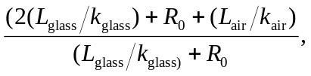
where 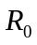 is the thermal resistance of the air films. Numerically, the ratio is

